**Communicate**

We made our video based on the game – *Animal Crossing*. Since the game can imitate scenarios of an elderly’s life vividly, and the player can add various electronic appliances in the protagonist’s home, the audience can understand the status of an elderly’s life intuitively.

The video is divided into 2 sections. In the first section, we show the life track of an elderly occupant in the form of a diary. There are 4 small videos in the bottom to highlight the appliances usage.

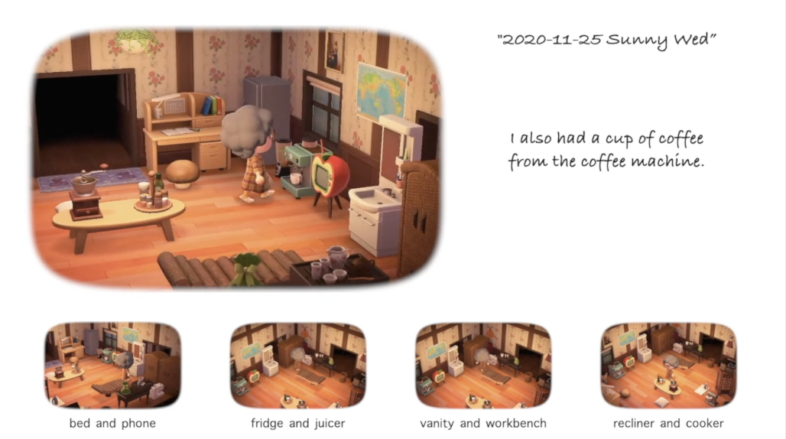

In the second section, we present how we use data to improve the nursing home’s services through 4 parts.

In the first part, we choose 3 homes with special occupants --- a cerebral palsy patient, a wheelchair user, and a person who likes cleaning, to show their one day life. Each small video is surrounded by 2 circles, which represent 24 hours. The clock within circles aims to give the audience a sense of time passing. Rotating icons with colorful traces show which appliance is being used in each hour.

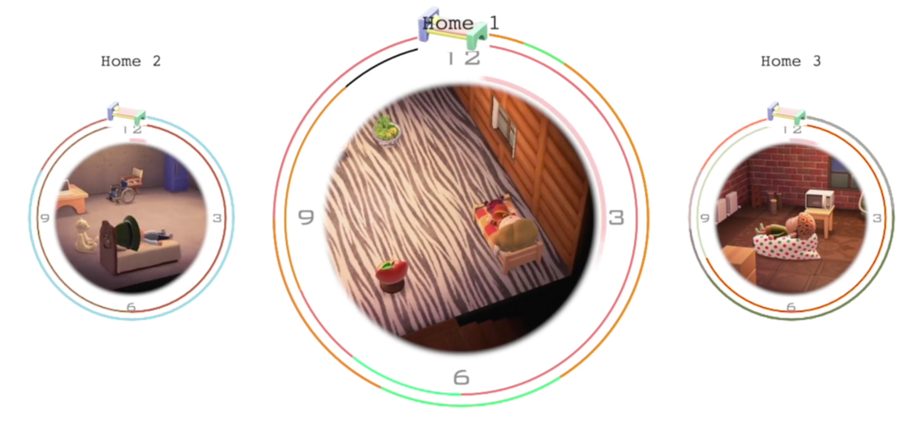

In the second part, we display a histogram to show the number of using times for different appliances and present a scenario of staff selecting appliances to demonstrate our use of data.

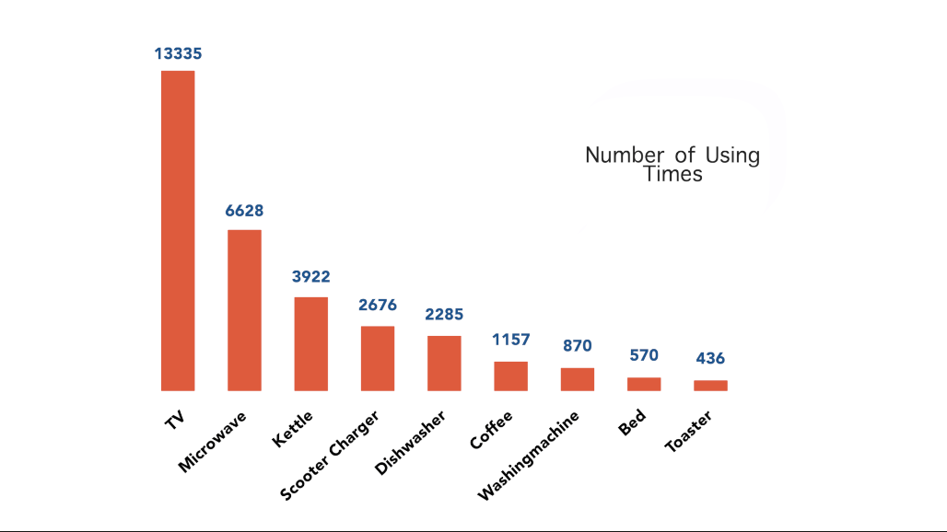

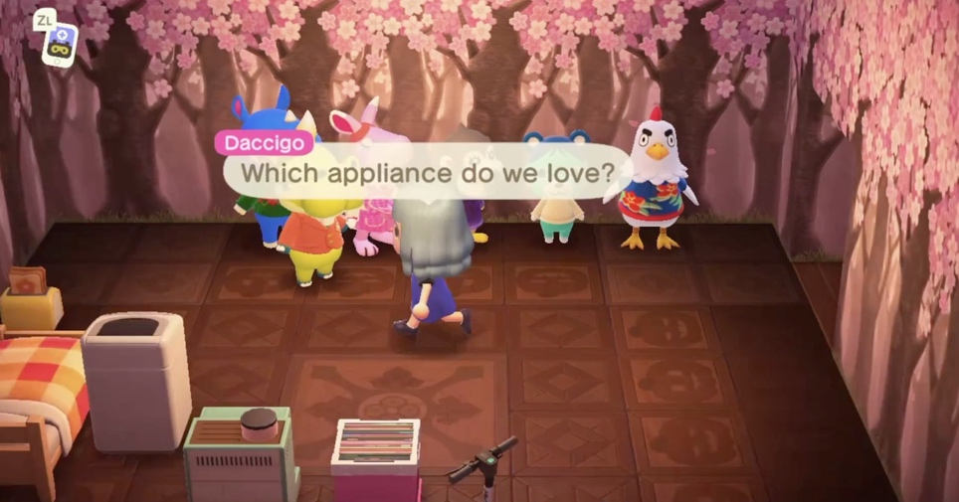

In the third part, besides the histogram of usage time for appliances, we use progress bars to indicate the depletion process and color the bar with red when it is approaching 80% to give a sense of warning. The little girl on the left side shows various facial expressions when it comes to different use conditions of appliances.

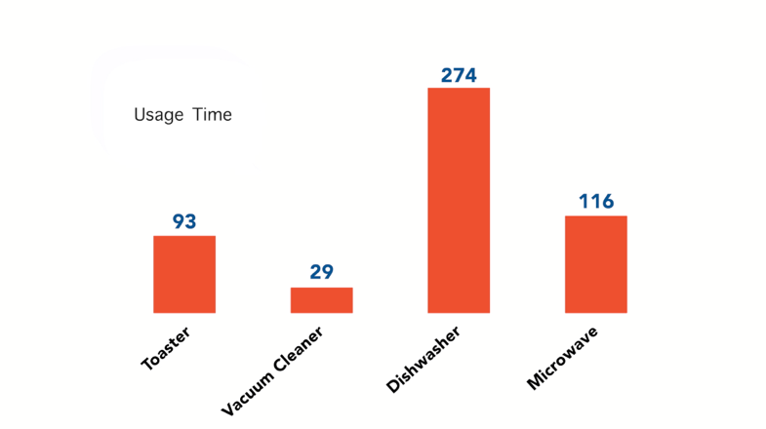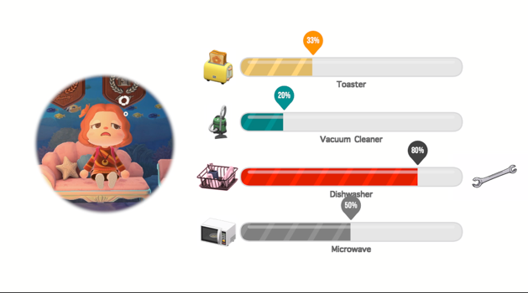

In the final part, we display a line diagram of abnormal usage frequency of the vacuum cleaner in a home. We color the anomalous interval in red to indicate possible abnormality of the occupant. When this case occurs, a staff will visit the corresponding occupant to see if he or she has an emergency, which can be seen in the last frame.

